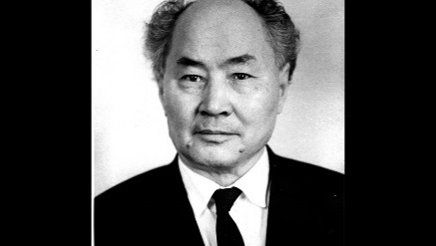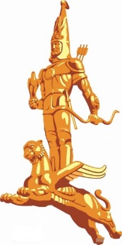

Ministry of Science and Higher Education of the Republic of Kazakhstan

NPJC «Pavlodar Pedagogical University after Alkey Margulan

INFORMATION LETTER

Dear colleagues!

NPJC “Pavlodar Pedagogical University after Alkey Margulan” invites you to take part in the International scientific and practical conference" Scientific heritage of academician A. Kh. Margulan and current problems of historical science of Kazakhstan"
Conference will be held on May 12, 2022 on the basis of NPJC “Pavlodar Pedagogical University”.

Format of the event: online\offline.

Public and political figures, teaching staff of universities of the Republic of Kazakhstan, countries of the near and far abroad, postgraduates, doctoral students and undergraduates are invited to participate in the conference.
Working languages: Kazakh, Russian and English.

The following sections will work during the conference:
- Alkey Margulan: a man, a scientist, a philosopher
- Actual problems of History, Source Studies and Historyography.
- Philological Sciences nowdays
- Today’ problems of teaching subjects of the natural-mathematical cycle
- Today’ pedagogy and directions of development in education

Applications of participants/Registration and texts of reports are accepted until April 25, 2022

 | Section | e-mail | Responsible
1 | Alkey Margulan: a man, a scientist, a philosopher | infor96@mail.ru | Tusupov Aybek Ruslanovich
2 | Actual problems of History, Source Studies and Historyography. | alinashvetc@gmail.com | Shvets Alina Nikolaevna
3 | Philological Sciences nowdays | aizhanym_pvl-city@mail.ru | Akhmetbekova Aizhan Zhanbolatovna
4 | Today’ problems of teaching subjects of the natural-mathematical cycle | nukenov@mail.ru | Nukenov Aybar Saparovich
 | 5) Today’ pedagogy and directions of development in education | musatila@mail.ru | Musatila Laura Mustapakyzy

There is no registration fee for participation in the forum.

The accepted reports will be published in the form of a collection of conference materials in electronic format.
The originality of the article should be at least 60%. Verification can be carried out via antiplagiat.ru , exactus.ru or any other free services. The certificate of passing the plagiarism check is accepted in JPG formats (screenshot) or PDF, the title of the article/author should be clearly visible on it. References that do not meet the requirements will be rejected.
The Organizing Committee reserves the right to reject materials that do not correspond to the topic of the conference, scientific standards or technical requirements. The Organizing Committee does not involve editing the text of publications. The author is responsible for compliance with scientific and research ethics for the submitted publication.

REQUIREMENTS FOR THE PRESENTATION OF THE REPORT

- The text of the report of no more than 6 pages in the MS WORD editor (6.0 or 7.0). The total volume includes illustrations, appendices and a list of sources. The file is given a name: for example, "Full name of the author (initials and surname) _name of the article";
- Font - Times New Roman; Size 14; line spacing - single, margins: left - 3 cm, the rest - 2 cm. Paragraph indentation is set automatically (red line 1.25 cm). It should not be decorated with multiple spaces and tabs. Pages are not numbered;
- At the top of the page is the title of the report given in capital letters (in bold), under it aftfter a space, the initials of the name and patronymic, surname, place of work;
- Abstract in Kazakh, Russian, English in italics (no more than 100 words);
- Key words (not more than 7);
- References and references are indicated at the end of the text of the article.
The links are in-text in square brackets: [1, p. 43-45], if several sources need to be specified in the link, they are given in parentheses separated by semicolons: [2, p. 1; 19, p. 10-12].
Illustrations (high-quality black-and-white drawings and clear photos with an extension of at least 300 dpi) are provided as separate files (.jpg or .tif), the name of which indicates the surname of the author and the number of the drawing.
In the text of the article where the author plans to place the illustration the inscription is contains:
- Type ("Figure", "Table", etc.) and serial number in Arabic numerals (without the number sign);
- The name of the illustration;
- For maps and drawings there must be an explication that explains the symbols, scale.
The references to illustrations and appendices are given in parentheses in the text: (Fig. 2), (see Appendix 1) If there are appendices in the article, they are numbered and titled. The details of the source must be specified at the end of the application. If there are abbreviations or the list of sources and literature in the text, it’s necessary to decipher them in a special list of abbreviations at the end of the article.

Sample the material design of:
«KIPCHAK STATEHOOD IS THE BASIS OF KAZAKH STATEHOOD»

Full name of the author (initials and surname) Pavlodar Pedagogical University after A. Margulan, Pavlodar city
e-mail

Annotation. The article is devoted to the problem of continuity of the state traditions of the Kipchak Khanate and the Kazakh Khanate. The paper shows the general and special features of the statehood of medieval nomads. The analysis of historical sources on the studing topic is given in the article.
Key words: Kipchak Khanate, Kazakh Khanate, nomadic statehood.

Text Text Text Text Text Text Text Text Text Text Text Text Text, Text [3, с. 47]. Text Text текст Text Text Text Text Text Text Text Text Text Text Text: «Citate»

Reference

Reference

